**Jamaine Grace Tuazon**

**COM23P – Introduction to Computing**

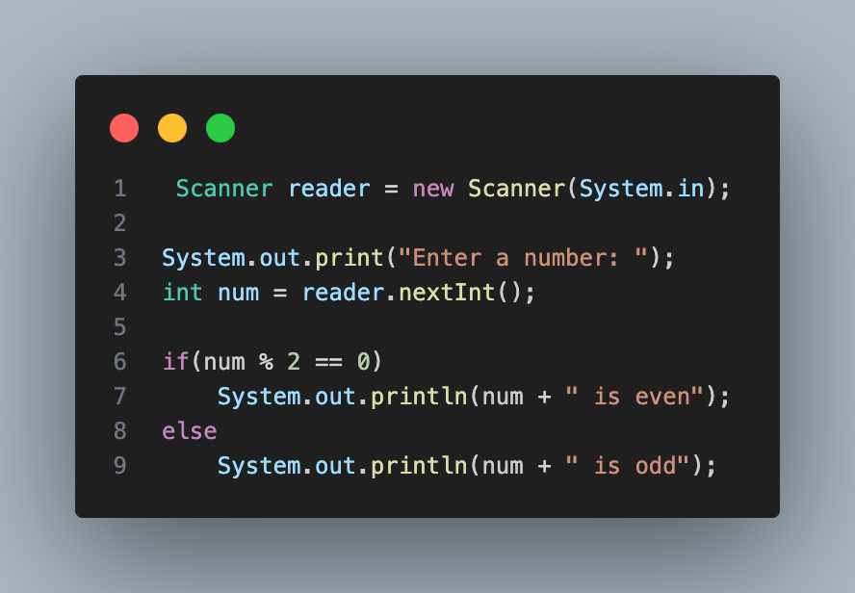

Pseudocode:

**OUTPUT** “Enter a number: ”

num <-- user input

**IF** num is divided to 2 and the reminder is equal to zero **THEN**

**OUTPUT**  num “ is even”

**ELSE**

**OUTPUT** num “ is odd”